Model: 2.5M ICON MINI

ICON
SPECIFICATION
WIFI USERNAME WIFI PASSWORD NO. OF PANELS NO. OF WIRES NO. OF JOINERS NO. OF BAGS NO. OF RUBBER WASHERS
PANEL DIMENSIONS
esaicon*yournumber* SportsArena1
6
6
12 pairs
6 or 0 (additional extra)
12 (2 required per panel) 500mm x 1250mm



6

CONTROL PANEL FRONT

Lifting handles

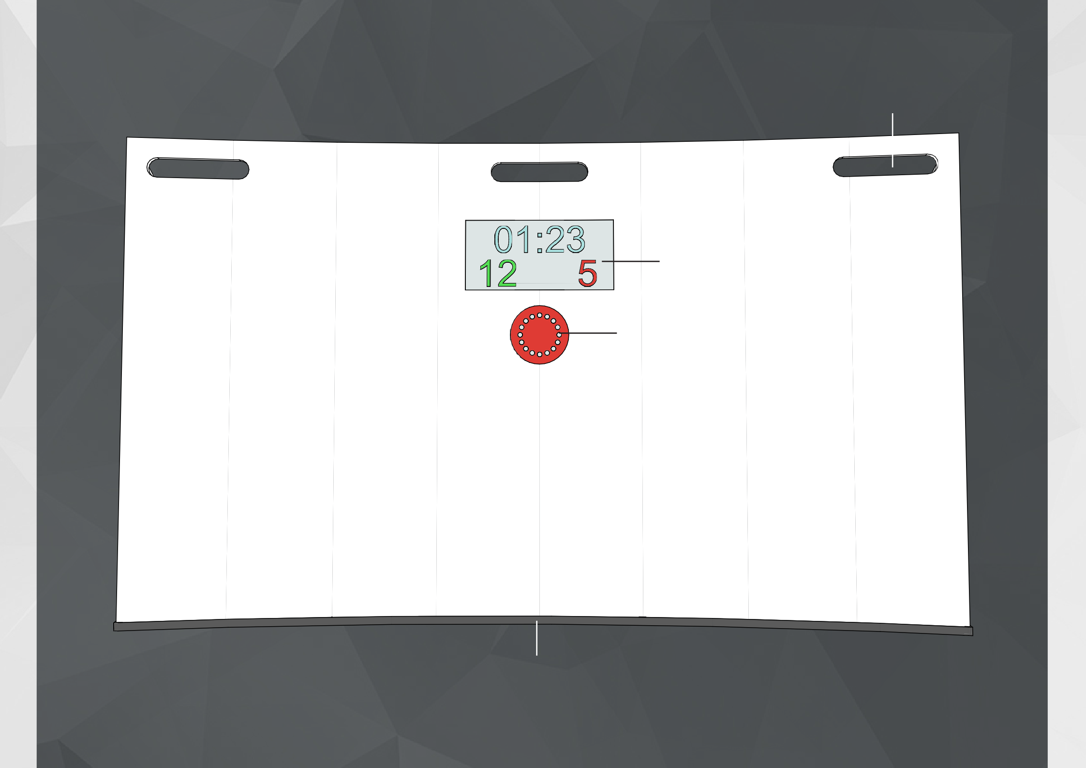

LED Electronic Score Board

LED light cluster

Rubber edge trim

10

CONTROL PANEL REAR

Lifting handles

Adjustable bolt slot

Cable stow

‘Restart previous game’ button
‘On’ button

Bolt hole



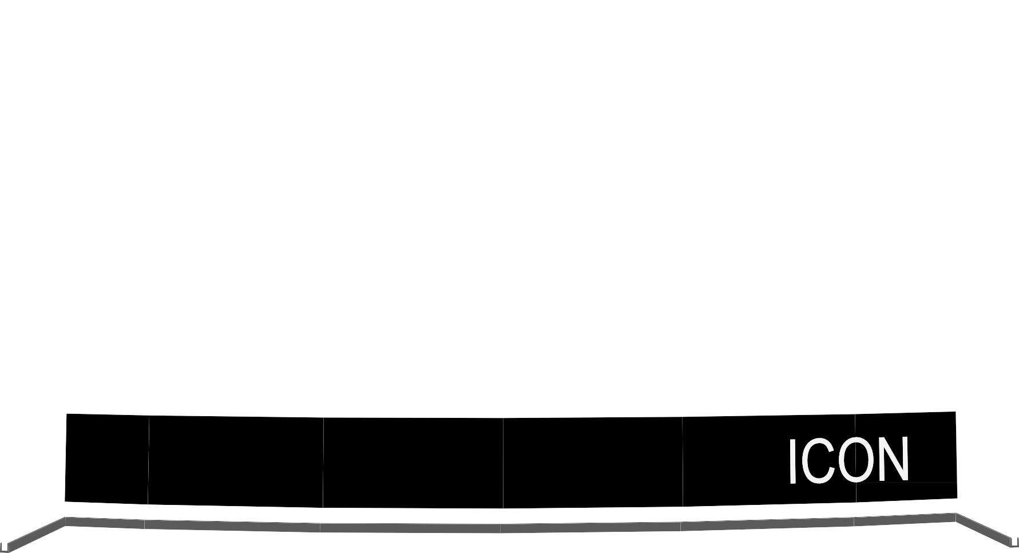



Control box with sliding access panel

Fixing screw seal

Rubber edge trim

11


TECHNICAL
INFORMATION
14

For any assistance on any technical aspect of the product, contact your ESA representa- tive for more information.

Functionality:

To control the ICON use the web interface.

Make sure you connect to the ICON wifi network first – The Wifi username will appear as esaicon(NUMBER) and the password is SportsArena1.

The web url is 10.110.110.10/frontpanel.htm. Type this URL into your browser to load
up the interface.

Note: The WIFI will take around 2 minutes to warm up.

For full operating instructions see page 17. Or the video sent by Elite Skills Arena.

For access to the ESA User Management database, to track players scores and data please contact ESA for more information on how to get started. Also, for information on the live and local leaderboards please view the initial set up instructions email sent by
Elite Skills Arena.


TECHNICAL
INFORMATION
15

Power supply:
- The arena comes with an external battery supply.

Battery:
The external battery has 6-8 hours’ battery life, can be used either indoors or outdoors and can be charged from any mains socket using the adapter.

Battery life will vary slightly on the game being played, and the brightness of the lights, the more lights in use consistently the shorter the life of the battery.

Note: Input (from mains to adapter) 100-240V AC, 3.0A max Output (from adapter to Battery) 14.6V, 10A
Output (from Battery to ICON) 30A Max, only 12.5A required.

When plugging the battery into the ICON, always ensure it is
placed in the bottom connector of the main panel. The connector is magnetic and will only go into the socket one way.

Battery Description:
Leoch Sealed Maintenance Free Lead Acid Battery.

The battery supply comes with full MSDS clarification, is suitable for shipping and is a sealed maintenance free lead acid battery.


OPERATING
INSTRUCTIONS
16

- Ensure all cables are in place correctly and the acrylic joiners are tightened sufficiently.

- Locate the ‘On Switch’ on the Scoreboard panel control box and hold down for 3 seconds.

- Wait for the arena to start up and only proceed when the scoreboard displays ‘ESA’.

- Go to your mobile/tablet/computer settings and locate WIFI. Select ESA ICON from the list of options and connect using the password provided ‘SportsArena1’. Once paired with the arena, load up the internet browser, and type in the URL for the Web interface: 10.110.110.10/frontpanel.htm

- Navigate the interface selecting the preferred training mode.

- Adjust settings such as duration, number of targets and countdown time to suit your session requirements (consult the training mode section of this guide for information on some of the games). Or consult the seperate training mode booklet.

- Use the start/stop button to start and stop training modes. Do not change the training mode whilst a game is running. Either stop the game or wait until it is completed before moving to a new game.

- The screen will now change into a running scoreboard while the mode is in progress and score and time remaining can be monitored on both the interface and the arena score- board in real time.

- To log in, click ‘Not logged in’ on the interface and follow the process using your provided username and password. To use festival mode, view email sent by ESA.

- To turn the ICON off, hold down the power button for 3-5 seconds, always make sure the ICON is fully off before removing the battery.


TRAININg
MODES
17

The ESA ICON arena has been designed to maximize training intensity through its unique curved design.

The arena is programmed with a pioneering LED target system which works with an innovative range of training modes.

Designed by professional coaches to develop player performance, all training modes are fully customisable and can be tailored to a coach’s preferences.

Select training mode and control the game duration, sound volume and LED brightness all from the ESA Interface.


PASS
FINDER
18
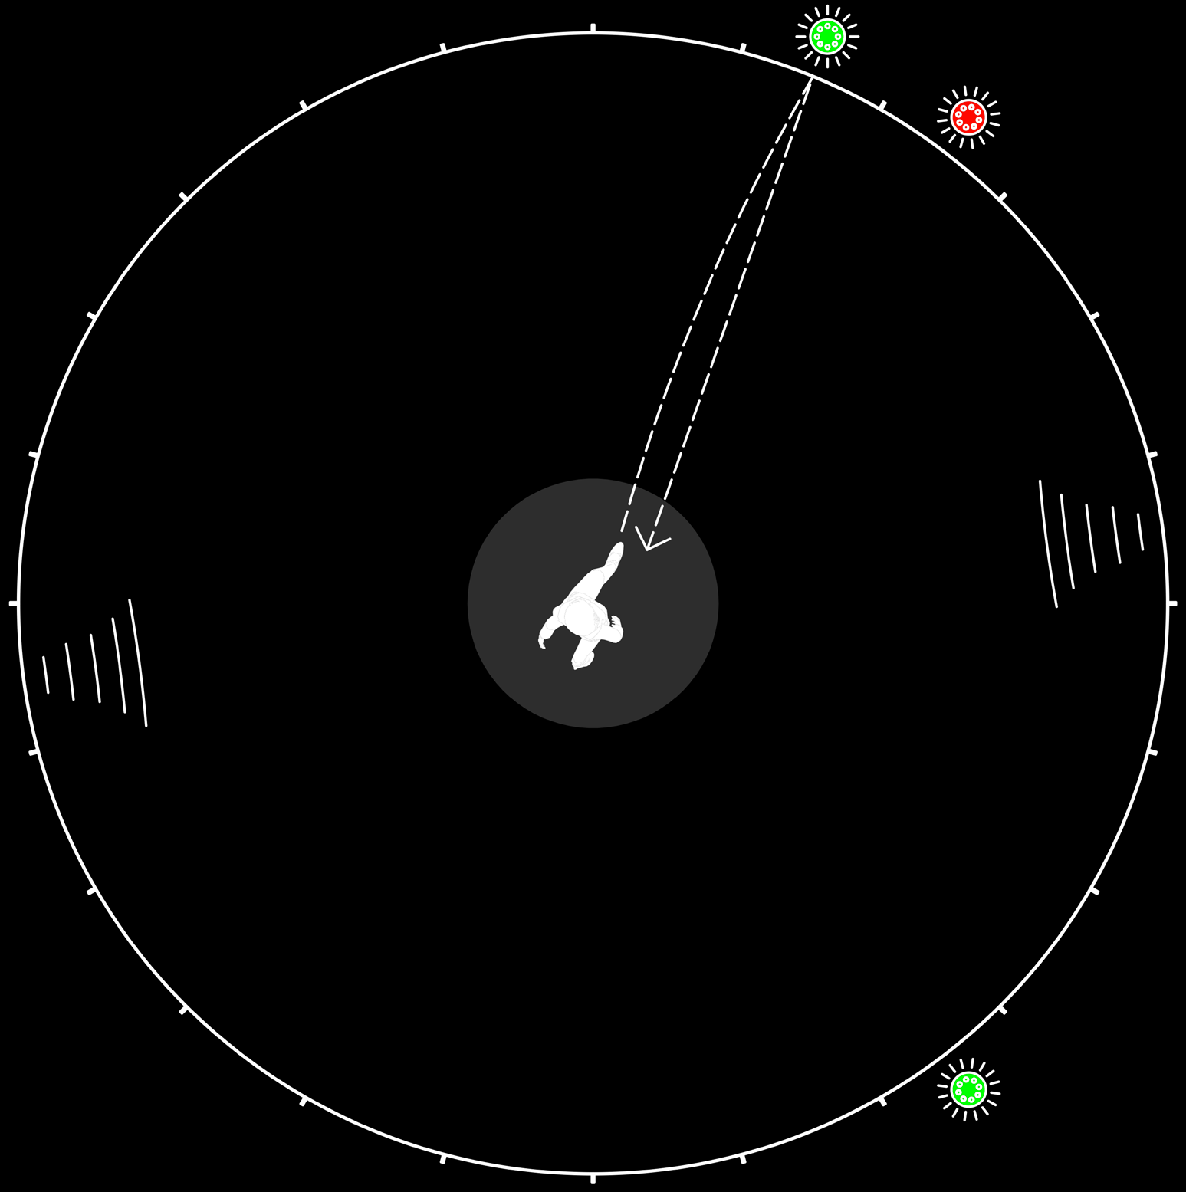
PassFinder is ESA’s flagship training mode. Designed around traditional passing drills, this mode displays lights randomly across the ICON and requires the performer to hit as many flashing lights as they can within the set time frame.

Alter the amount of targets displayed at a time to work on differing attributes, and incorporate mul- tiple players in a ‘spot’ or ‘set and pass’ game.


PASS FINDER
INSTRUCTIONS
19

- One/two/three (depending on training mode) LED target/s are displayed at random inside the ICON.

- Target disappears when successfully hit and reappears elsewhere

- If a target is missed, the panel that has been struck will light up red and the correct target will stay on until it has been successfully hit.

- Sound effects and LED lights indicate when a target has been hit, and also will inform you of the end of the training session.

- Scoreboard displays successful hits as well as unsuccessful. The scoreboard will also show the timer countdown.

- Game ends at the end of the timer countdown and the number of successful hits are recorded.

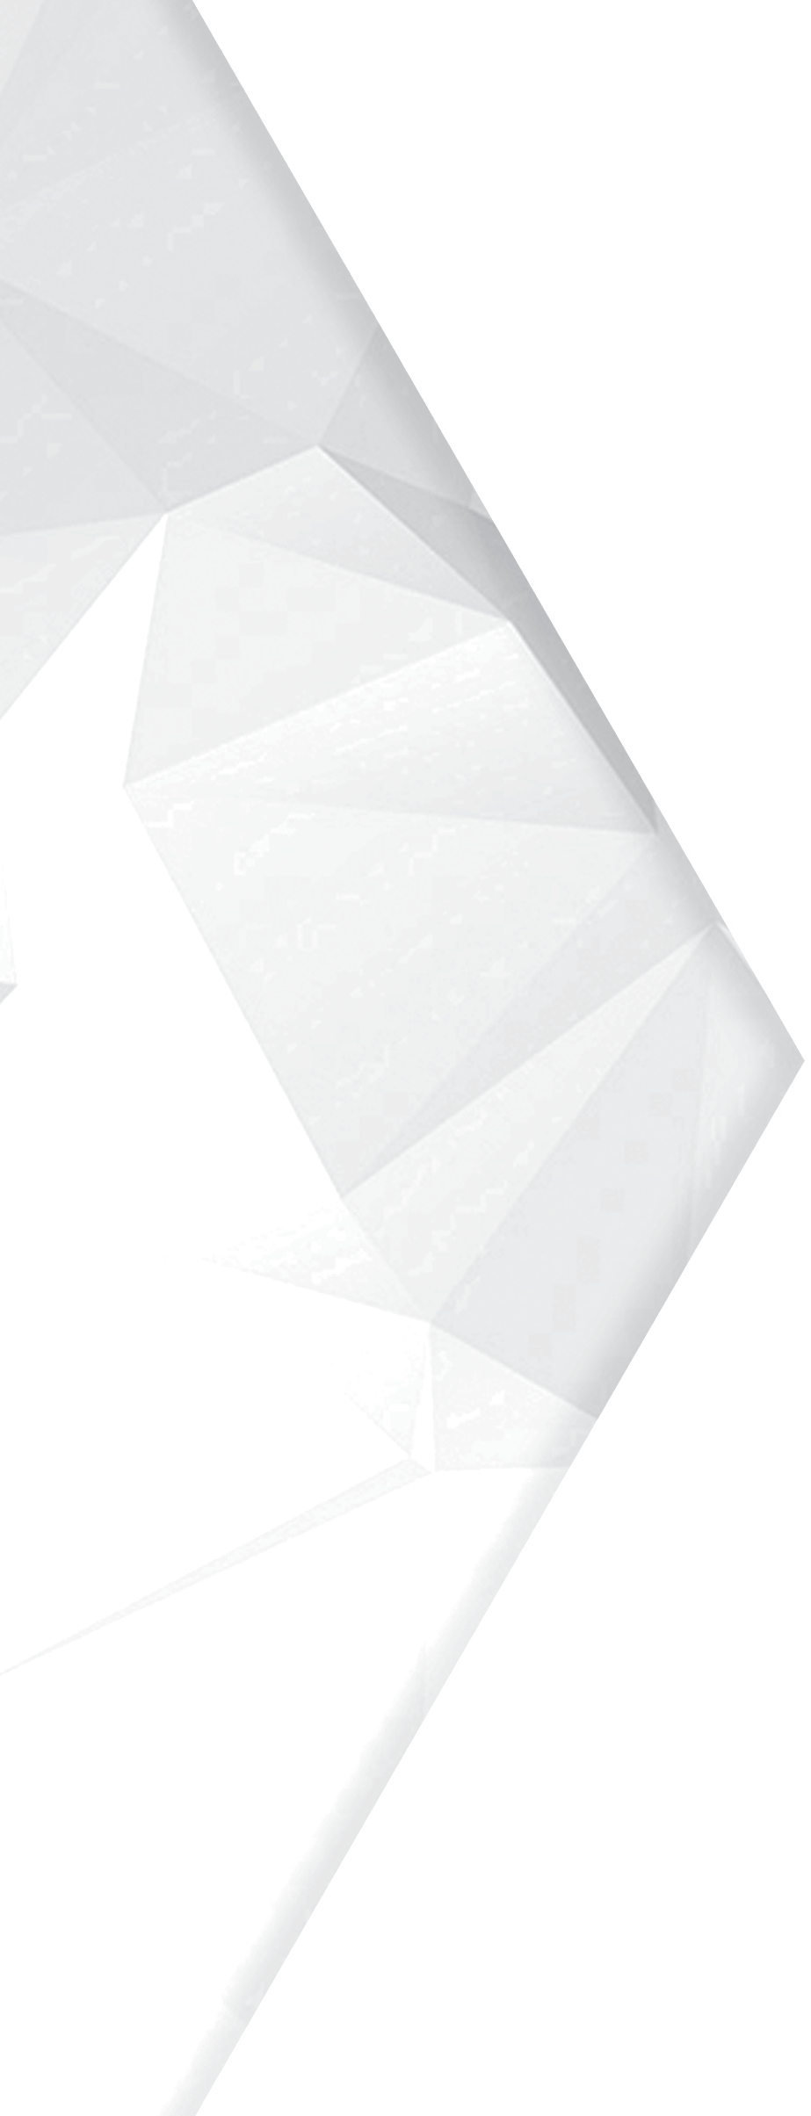
PASS
FINDER PLUS
20

Developed alongside the professional coaches from Liverpool FC.

During PassFinder Plus, 1 single blue light will flash for 2 seconds (this duration can be tailored depending on ability), the player must hit the blue light within 2 seconds or it will move randomly to any other panel in the ICON circle.

This training mode punishes a poor first touch or pass and is very physically demanding, encour- aging good technique.


PASS FINDER PLUS
INSTRUCTIONS
21

- 1 LED target is displayed at random to hit as quickly as possible.

- Initial target on for 2 seconds (time can be altered).

- After 2 seconds if target is not hit, target will appear randomly elsewhere inside the ICON arena.

- Each individual target will remain on for 2 seconds only.

- 1 point for each target successfully hit.

- Sound effects and LED lights indicate when a target has been hit.

- Scoreboard displays number of successful hits, and overall game time.


MAESTRO
22
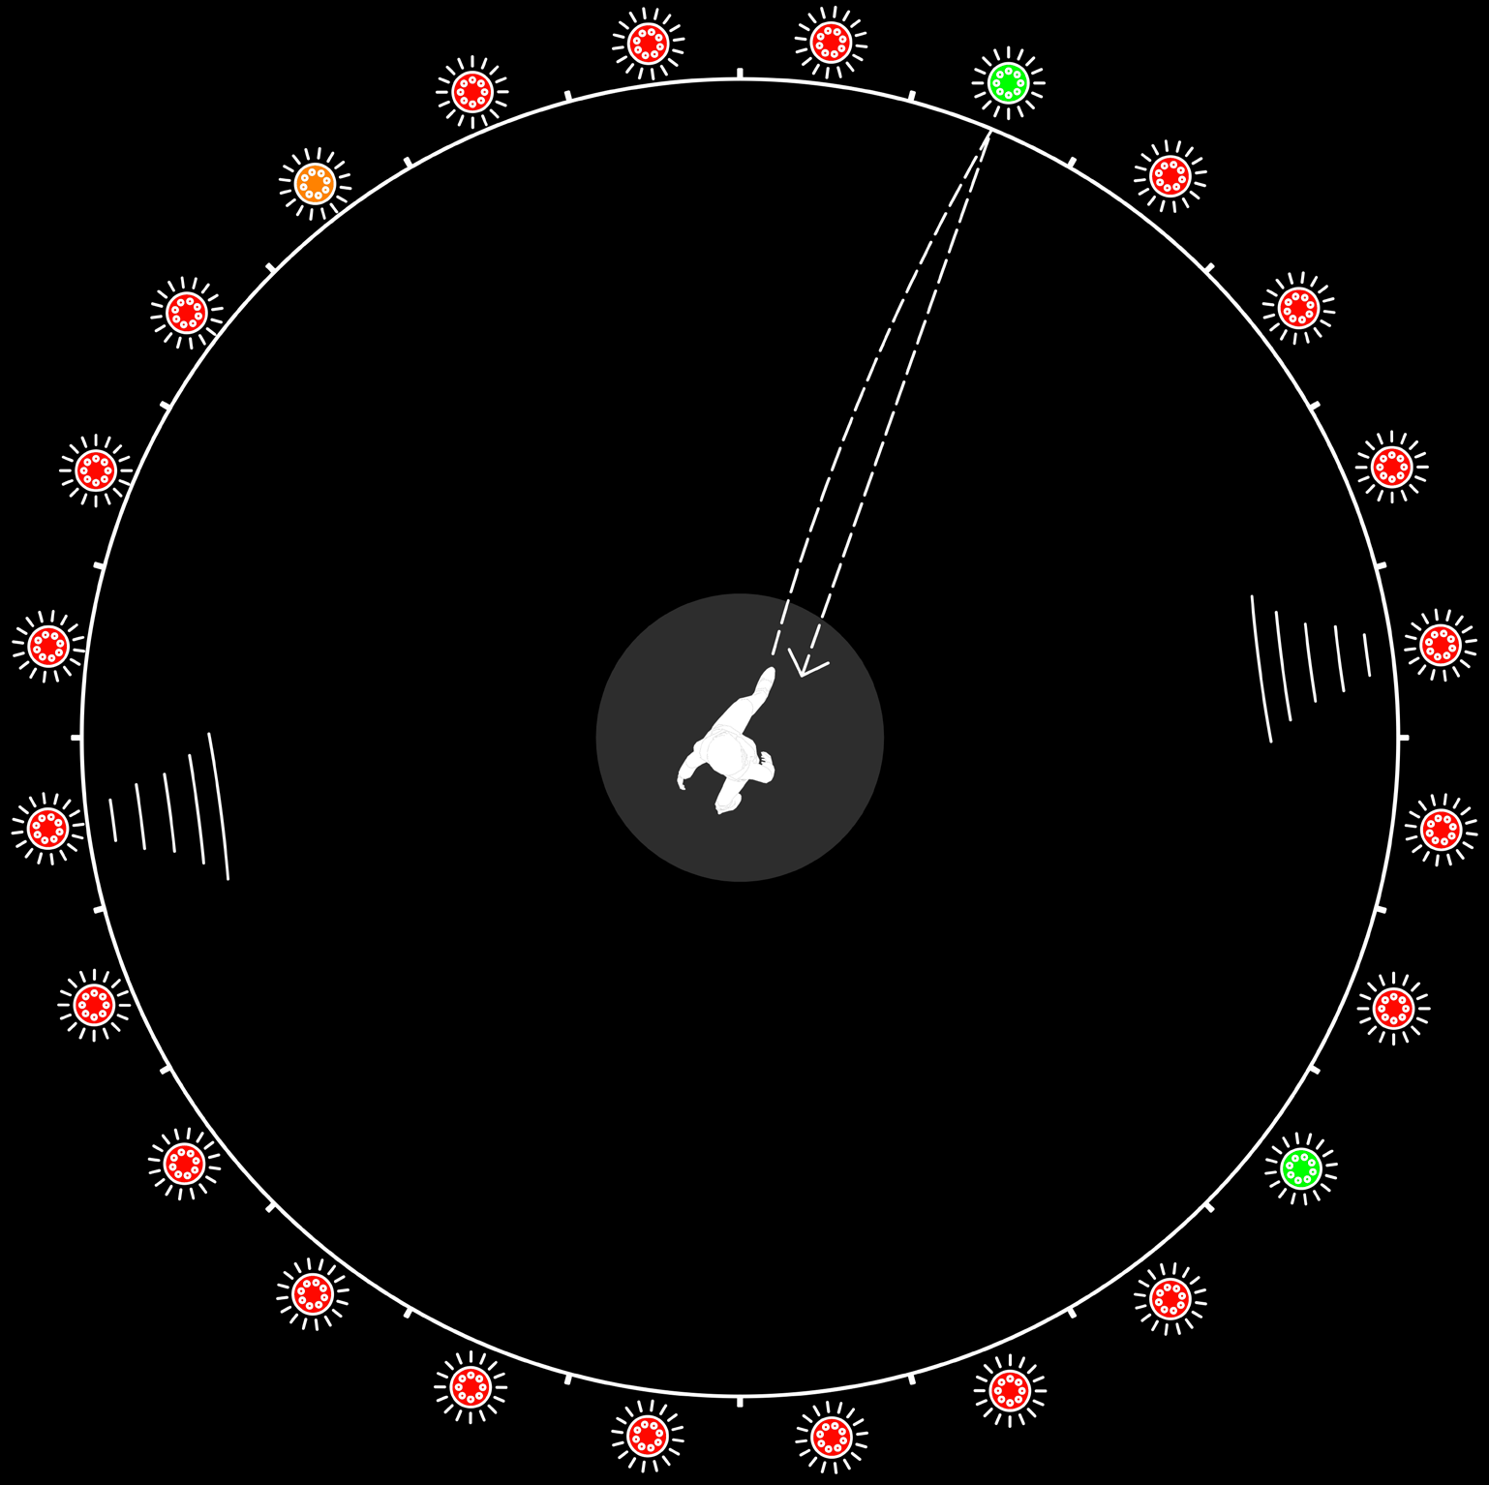
Accuracy is vital when playing Maestro, with points deducted for missing a pass.

During training, 2 green lights are on at any time, worth 3 points, with one orange worth 1 point, all other lights are lit red and are worth -1 point.

When playing Maestro, good decision-making is essential to get a good score.

An orange light may be easily attainable but only worth 1 point and so going for a harder option of a green pass could be rewarding.


MAESTRO
INSTRUCTIONS
23

  - Get as many points as possible by hitting orange or green targets.

  - Variable time limit.

  - 1 LED target is displayed ORANGE at random inside the arena.

  - 2 LED targets are displayed GREEN at random inside the arena.

  - All remaining LED targets are displayed RED inside the arena.

  - -1 point is awarded for hitting RED targets, +1 for ORANGE, +3 for GREEN.

  - ORANGE and GREEN Targets disappear when successfully hit, and reappear randomly.

  - RED targets remain on when hit.

  - Sound effects and LED lights indicate when a target has been hit.

  - Scoreboard displays number of points, and timer countdown.

  - Game ends at the end of the timer countdown and the total number of points are recorded.

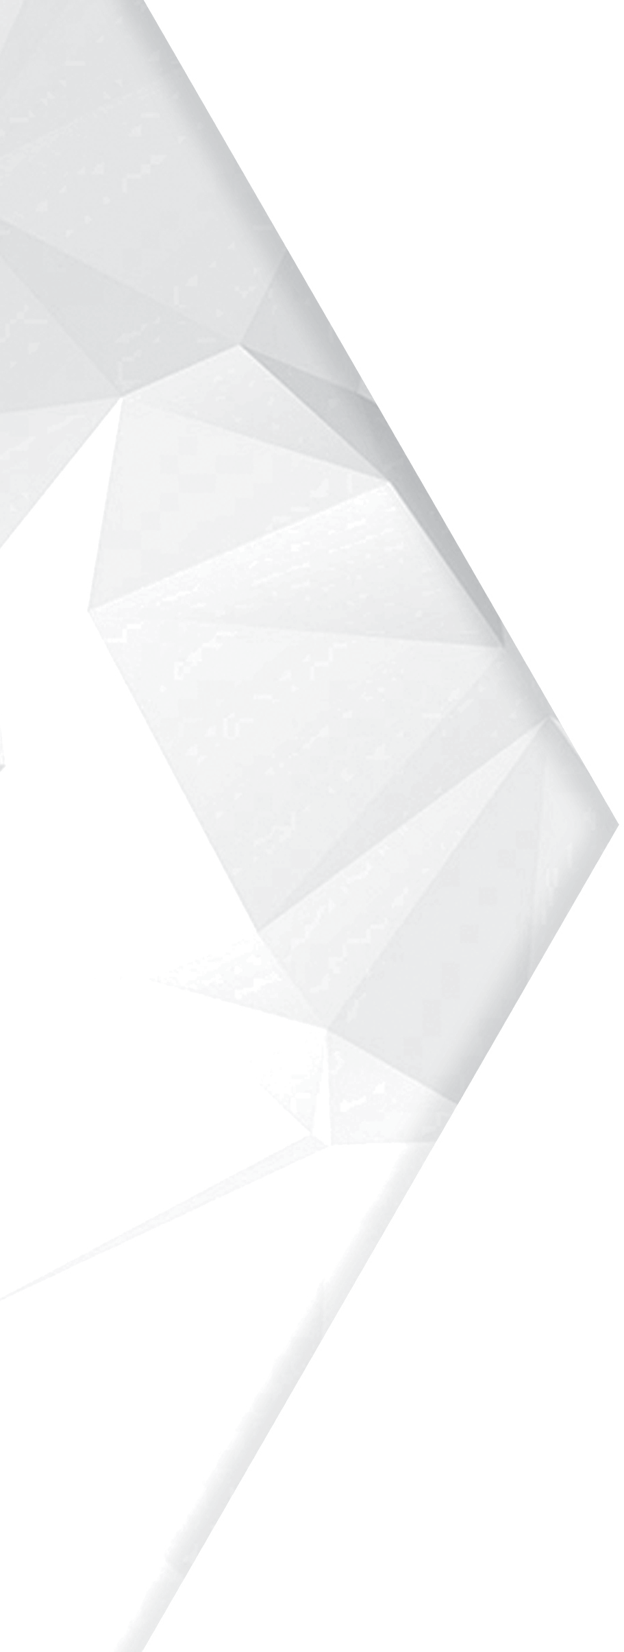
KNOCK
OUT
24
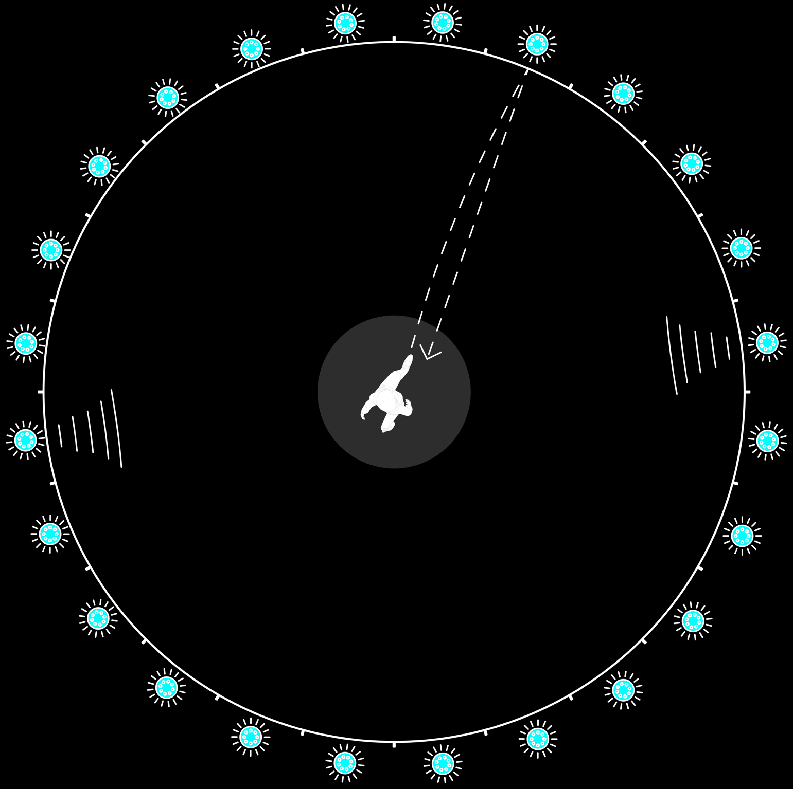
Knockout is a quick-fire training mode, and an extremely effective warm up or rehabilitation rou- tine.

All lights flash blue across the ICON and you must hit each of them as quickly as possible. The scoreboard counts your time and the shorter the better.

Tailor this training mode to suit your needs, for example use alternate feet to make each pass.

    - All lights come up flashing white.

    - Countdown of 5 seconds.

    - Player must hit all the lights out as quickly as possible.

    - Each light turns green when hit.

    - Timer stops when all lights have successfully been hit. The lights can be struck out in any order.

    - If a light has already been hit, it will no longer flash, and if hit again will turn red to indicate an unsuccessful pass.

    - The scoreboard will indicate when finished how long it has taken the player to complete the challenge.
KNOCK OUT
INSTRUCTIONS



25

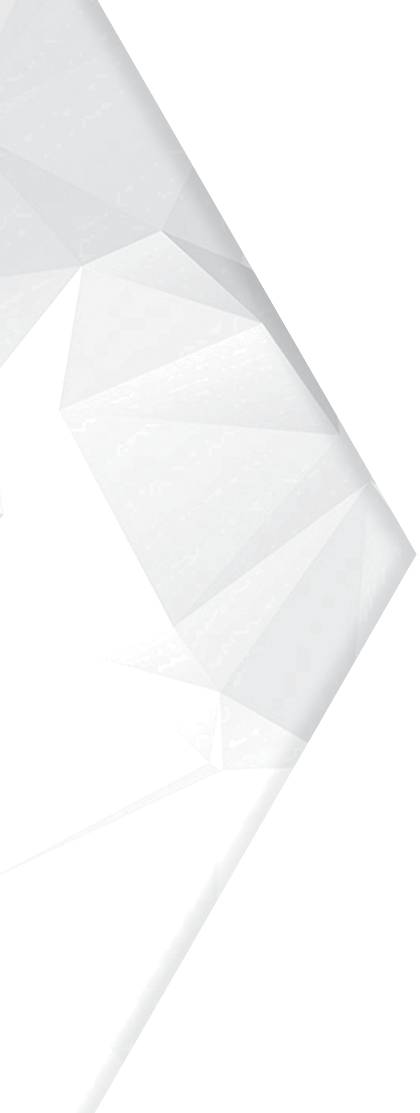



VISION

Vision is a training mode developed for two purposes: Firstly, the Vision sequence uses the same light pattern each time it is played, meaning aspiring players can accurately compare their score to their heroes.

Secondly, Vision is extremely beneficial for developing ‘scanning/checking your shoulder’ abilities. During this training mode, two lights will appear at each individual time.

During this training mode, two lights will appear at each individual time. One blue, which is the light which needs to be hit initially, and one orange, which provides a visual stimulus to show where the next pass should be played. Once the first (blue) light is hit, the orange light will change to blue and become the next available light to be struck.
26

- One blue target displayed at random. One orange light also displayed.

- Target disappears when successfully hit and reappears elsewhere.

- If a target is missed, the panel that has been struck will light up red and the correct target will stay on until it has been successfully hit.

Once the blue target has been hit, the previously orange light will
- change to blue and become the next target to hit.

A further orange light will then appear so the performer is always
- aware of where their next pass will be.

Sound effects and LED lights indicate when a target has been hit,
- and also will inform you of the end of the training session.

Scoreboard displays successful hits as well as unsuccessful. The
- scoreboard will also show the timer countdown.

Game ends at the end of the timer countdown and the number of
- successful hits are recorded.

VISION
INSTRUCTIONS



27

